OVSDB (Open vSwitch Database Management Protocol)

The Open vSwitch Database Management Protocol (OVSDB) is an [OpenFlow](http://whatis.techtarget.com/definition/OpenFlow)configuration [protocol](http://searchnetworking.techtarget.com/definition/protocol) that is designed to manage Open vSwitch implementations.

Open vSwitch is a [virtual switch](http://searchservervirtualization.techtarget.com/definition/virtual-switch) that enables network automation, while supporting standard management interfaces and protocols, like [NetFlow](http://whatis.techtarget.com/definition/NetFlow-Cisco). Open vSwitch also supports distribution across multiple physical servers, in a way that’s similar to [Cisco’s Nexus 1000v](http://searchsdn.techtarget.com/definition/Nexus-1000V-Cisco-Nexus-1000V).

In an Open vSwitch implementation, a database server and a switch [daemon](http://searchmicroservices.techtarget.com/definition/daemon) are used. The OVSDB protocol is used in a control cluster, along with other managers and [controllers](http://whatis.techtarget.com/definition/controller), to supply [configuration](http://searchexchange.techtarget.com/definition/configuration) information to the switch database server. Controllers use OpenFlow to identify details of the [packet](http://searchnetworking.techtarget.com/definition/packet) flows through the [switch](http://searchtelecom.techtarget.com/definition/switch). Each switch may receive directions from multiple managers and controllers, and each manager and controller can direct multiple switches.

Using the OVSDB protocol, IT professionals can determine the number of individual virtual [bridges](http://searchsecurity.techtarget.com/definition/bridge) within an Open vSwitch implementation, allowing a network engineer to create, configure and delete ports and tunnels from a bridge. Engineers can also create, configure and delete queues.

Simply put, [Open vSwitch Database (OVSDB)](https://www.sdxcentral.com/projects/open-vswitch-database/) is a management protocol in a [software-defined networking (SDN)](https://www.sdxcentral.com/sdn/)environment. OVSDB was created by the Nicira team that was later acquired by [VMware](https://www.sdxcentral.com/listings/vmware/). Originally, was part of [Open vSwitch (OVS)](https://www.sdxcentral.com/cloud/open-source/definitions/what-is-open-vswitch/), which is a feature-rich, open source virtual switch designed for Linux-based hypervisors. Most network devices allow for remote configuration using legacy protocols, such as [simple network management protocol (SNMP)](http://en.wikipedia.org/wiki/Simple_Network_Management_Protocol). The focus with OVS was to create a modern, programmatic [management protocol interface](https://datatracker.ietf.org/doc/rfc7047/) – OVSDB was the answer.

[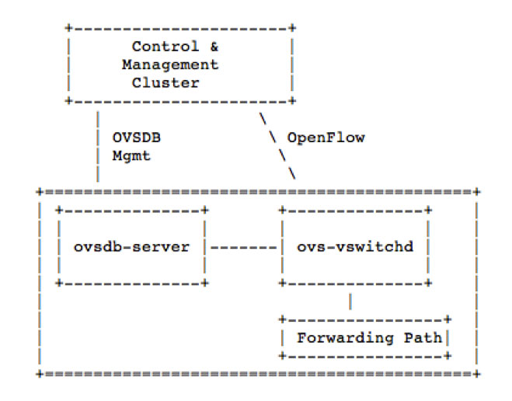](https://www.sdxcentral.com/wp-content/uploads/2014/09/ovsdb-diagram-sdn-openflow.jpg)

**Figure 3 – Source:**[**http://tools.ietf.org/html/draft-pfaff-ovsdb-proto-00**](http://tools.ietf.org/html/draft-pfaff-ovsdb-proto-00)

While it’s sometimes assumed [OpenFlow](https://www.sdxcentral.com/sdn/definitions/what-is-openflow/) can do it all, this is not the case. For [SDN Controller](https://www.sdxcentral.com/sdn/definitions/sdn-controllers/) deployments with OVS, OpenFlow is still used to program flow entries, but OVSDB is used to configure the OVS, itself. Configuring OVS means doing things like creating/deleting/modifying bridges, ports, and interfaces. If OVS is deployed in a standalone environment, there is no reason OVSDB can’t be used by itself to configure OVS (non-OpenFlow environment). While this is possible, very few standalone network management platforms really exist that support OVS or specifically, native OVSDB.

While OVSDB was introduced to the world, along with OVS, the Open vSwitch Database is now supported by more switch platforms, other than OVS. It is now being supported by network vendors, such as [Cumulus](https://www.sdxcentral.com/listings/cumulus-networks/), [Arista](https://www.sdxcentral.com/arista/), and [Dell](https://www.sdxcentral.com/listings/dell/), just to name a few. By supporting the Open vSwitch Database, these vendors are integrating their hardware platforms with [SDN](https://www.sdxcentral.com/sdn/definitions/what-the-definition-of-software-defined-networking-sdn/) and [network virtualization](https://www.sdxcentral.com/sdn/network-virtualization/) solutions.